THE ASSERTIVE ROOM: RESEARCH REPORT EMILA YANG  
  
Concept and Theme:  
The walls and ceilings in a room have a passive presence in our lives. They are plain, still, unresponsive and unobtrusive, providing us with a predictable space in which we can focus on other things.  
  
Our concept challenges the idea of a passive space and forces the viewer to suddenly be sharply aware of the presence of the room by bringing an element of the room (ceiling) into the viewer’s personal space.

Technical Implementation: Lights in the fabric  
LEDs and resisters can be sewn onto the fabric using conductive threads. The following video illustrates how it can be done:  
<http://www.youtube.com/watch?feature=player_embedded&v=YpmBh-jlkm4#>!  
  
We can use several types of conductive threads. We can use silver plated nylon 117/12 x 2ply thread, which is a fine, lightweight thread with a moderate resistance of 75-85ohm/foot depending on whether it’s stretched or loose. It is easier to work with on a sewing machine.  
  
The silver plated nylon 234/34 x 4ply thread is thicker and has a lower resistance of 14ohms/foot, however it frays more easily. Frays may cause problems such as short-circuiting so it’s best to be avoided.  
  
Aside from the plated threads, there are also stainless steel threads, which is harder to work with but has much lower resistance. For example a thin stainless steel conductive thread on Sparkfun Electronics has a resistance of 9ohms/foot while the thick thread has only 4ohms/foot. With the stainless steel thread, we may have to just lay it out on the fabric and hold it in place with an over-stitch of non-conductive material, or use materials such as glue.

To control LEDs individually, we could use shift registers such as the 74HC595, LED drivers such as Maxim MAX7219 or the Texas Instruments TLC5940 LED driver, or we could use the Charlieplexing method.  
  
If we are not controlling LEDs individually, it is possible to power a large number of LEDs by connecting to an external power source. (<http://forums.adafruit.com/viewtopic.php?f=8&t=16469>)  
  
The Arduino Uno with 14 pins can use shift registers such as the 74HC595 to increase the number of LEDs it can run (<http://arduino.cc/en/Tutorial/ShiftOut>). Multiple registers can be linked together to run more LEDs. Shift registers do not support fading of LEDs. The ShiftPWM library (<http://www.elcojacobs.com/shiftpwm/>) can be used to help program the LEDs.  
  
The LED drivers MAX7219 and MAX7221 are integrated circuits used to drive up to 64 individual LEDs using only 3 pins.

A method called Charlieplexing (<http://en.wikipedia.org/wiki/Charlieplexing>) can be used to drive more LEDs. We will need to look into this a bit more after gaining more basic electronics knowledge.  
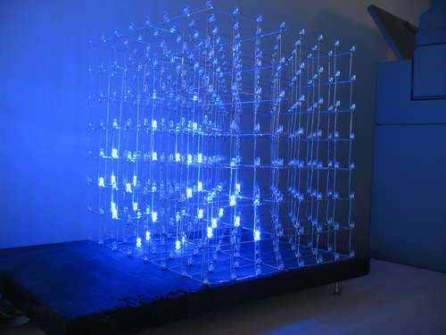

We can consider using Arduino Lilypad 328 Main Board (digital I/O: 14, analog inputs: 6, PWM: 6) to run the LEDs so it can move with the fabric. The Lilypad can be sewn onto fabric using conductive thread to establish electrical as well as physical connections.

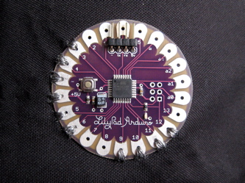  
  
**COSTS:**  
Lilypad Arduino 328 Main Board costs $21.95

65m of conductive thread with 14Ohm resistence costs $34.95  
8-Bit Shift Register 74HC595 costs $1.50  
LEDs costs from $0.35 - $1.50, but can be much cheaper on sites like eBay, where we can get 20 pieces for $3.70  
Maxim MAX72xx can cost around $5 - 11 each